**Acknowledgement**

Finally Iwould like to express our appreciation to ou capstone project guide ,our department HOD Mr K.P Akole sir. His constant guidance advice palyed a vital role in making the execution of the report. He always gave his required suggestions that were crucial in making report better. Guidance of the our sir has consistently keep us motivated for project planning. He has taken every possible step to improve us not only in a project but also in social activities which were going to improve our project and working attitude towards our project. We again thank you sir for your support.

**Abstract**

The project which we are going to make covers two major steps

1. It is based on the live industrial problem which is shared by company itself (Spectrum Electrical Ltd)
2. And company itself is ready to give the technical sponsorship required for the project

The problem given by the industry is that in the electroplating plant of the industry there is a need of a system which require to monitor a parameters such as liquid PH value,Methane and carbon monoxide gases content of electroplating bath container not only monitoring but the want the data to be fetched in their plant office with wireless technology

So the solution for these problem can be to construct the system which will measure such parameters from bath and transmit into the office. These parameters which are water, PH level, Carbon Monoxide gas, methane gas temperature of electrolyte solution can be sensed by the sensors. Sensors output will be feed to the controller where the sensed parameter will be converted in the real time readable format and further send to the office through the transmitter module. At the reception section of the system this data will be displayed on the lcd screen and system such as, if the measured parameter value rises above the required level a small alaram will activate which will inform that parameters of bath had exceeds its tolerating value

So to complete the project successfully we have to do the literature survey of the components required for the project for eg literature survey of the sensors for given task, their compatibility with the controller survey of display devices the compatibility with controller , effective rf module to meet the wireless range for the display of data, to choose the appropriate programming environment,study of all the programming knowledge to programm the components and last but not least simulation of the complete project and last its implementation in the industry.

**Index**

|  |  |  |
| --- | --- | --- |
| **Sr no** | **Topic name** | **Page no** |
| 1 | Chapter 1. Introduction of the Capstone project | 8 |
| 2 | Chapter 2 : Literature survey Done for selecting a problem identification for Capstone project | 9 |
| 3 | Chapter 3 -:detailed methodology of capston project | 10 |

**Chapter 1: Introduction of the Capstone project**

**Process** like deposition ,doping, electroplating creates the toxic gases in the processing plant. This gases are used as a catalyst in the process. This gases sre surely enabler in the processing but are highly toxic and can cause concussion when inhaled. Additional acids like HCL are also used in these companies for similar purpose fumes can cause irritation & affect the respiration of the inhaler Whether these gases are used for manufacturing or byproducts of any process in a facility it becomes very important to monitor and control them.

Therefore gas detection system can be easily integrated into existing system & equipment of a company, allowing easy detection of gas leakages that can result in several catastrophe. Quick action can hence be taken to prevent the spread of gas over a wide region. These systems are an essential commodities in such industries. Since the allow them to detect the leakage of noxious and explosive gases maintain proper oxygen level for workers and company with emission regulation norms.

Gas sensors (also known as gas detectors) are **electronic** devices that detect and identify different types of gasses. They are commonly used to detect toxic or explosive gasses and measure gas concentration. Gas sensors are employed in factories and manufacturing facilities to identify gas leaks, and to detect smoke and carbon monoxide in homes.

Gas sensors vary widely in size (portable and fixed), range, and sensing ability. They are often part of a larger [embedded system](https://www.fierceelectronics.com/embedded/what-embedded-computer), such as security systems, and they are normally connected to an audible alarm or interface. Because gas sensors are constantly interacting with air and other gasses, they have to be calibrated more often than many other types of sensors.

MQ2 is one of the commonly used gas sensors in MQ sensor series. It is a Metal Oxide Semiconductor (MOS) type Gas Sensor also known as **Chemiresistors** as the detection is based upon change of resistance of the sensing material when the Gas comes in contact with the material. Using a simple voltage divider network, concentrations of gas can be detected.

An **RF module** (short for **radio-frequency module**) is a (usually) small electronic device used to transmit and/or receive radio signals between two devices. In an [embedded system](https://en.wikipedia.org/wiki/Embedded_system) it is often desirable to communicate with another device [wirelessly](https://en.wikipedia.org/wiki/Wireless). This wireless communication may be accomplished through [optical communication](https://en.wikipedia.org/wiki/Free-space_optical_communication) or through [radio-frequency](https://en.wikipedia.org/wiki/Radio-frequency) (RF) communication. For many applications, the medium of choice is RF since it does not require line of sight. RF communications incorporate a [transmitter](https://en.wikipedia.org/wiki/Transmitter) and a [receiver](https://en.wikipedia.org/wiki/Receiver_(radio)). They are of various types and ranges. Some can transmit up to 500 feet. RF modules are typically [fabricated](https://en.wikipedia.org/wiki/Semiconductor_device_fabrication) using [RF CMOS](https://en.wikipedia.org/wiki/RF_CMOS) technology.

RF modules are widely used in electronic design owing to the difficulty of designing radio circuitry. Good electronic radio design is notoriously complex because of the sensitivity of radio circuits and the accuracy of components and layouts required to achieve operation on a specific frequency. In addition, reliable RF communication circuit requires careful monitoring of the manufacturing process to ensure that the RF performance is not adversely affected. Finally, radio circuits are usually subject to limits on radiated emissions, and require [Conformance testing](https://en.wikipedia.org/wiki/Conformance_testing) and certification by a [standardization](https://en.wikipedia.org/wiki/Standardization) organization such as [ETSI](https://en.wikipedia.org/wiki/ETSI) or the U.S. [Federal Communications Commission](https://en.wikipedia.org/wiki/Federal_Communications_Commission) (FCC). For these reasons, design engineers will often design a circuit for an application which requires radio communication and then "drop in" a pre-made radio module rather than attempt a [discrete](https://en.wikipedia.org/wiki/Discrete_device) design, saving time and money on development.

Several carrier frequencies are commonly used in commercially available RF modules, including those in the [industrial, scientific and medical (ISM) radio bands](https://en.wikipedia.org/wiki/ISM_band) such as 433.92 MHz, 915 MHz, and 2400 MHz. These frequencies are used because of national and international regulations governing the used of radio for communication. [Short Range Devices](https://en.wikipedia.org/wiki/Short_Range_Devices) may also use frequencies available for unlicensed such as 315 MHz and 868 MHz.

RF modules may comply with a defined protocol for RF communications such as [Zigbee](https://en.wikipedia.org/wiki/Zigbee), [Bluetooth Low Energy](https://en.wikipedia.org/wiki/Bluetooth_Low_Energy), or [Wi-Fi](https://en.wikipedia.org/wiki/Wi-Fi), or they may implement a [proprietary protocol](https://en.wikipedia.org/wiki/Proprietary_protocol).

**Chapter 2 : Literature survey Done for selecting a problem identification for Capstone project**

First we have decided top make a project to make full body sanitizer machine for the department. We were very close to find a effective way to make our product cost effective,and were studying on how to introduce our product to market. But while working on it we find out the type of product which we are going to make was restricted to use on because of some harmful effects of liquid sanitizer on the human beings. So we quit our working on that project

Then we try to reach the various industries to get the problem statement so we can try to find out the solution the it as our project. Then we get a belove given problem which was given by the Spectrum Electrical Industry Pvt.Ltd.

The problem given by the industry is that in the electroplating plant of the industry there is a need of a system which require to monitor a parameters such as liquid PH value,Methane and carbon monoxide gases content of electroplating bath container not only monitoring but the want the data to be fetched in their plant office wirelessly

Methods for solution the identified problem can be as follows

**Flexible system** -: System shiuld be so flexible which will easily adapt the electroplating plant environment.and can be easily transferred to another container. Also if require it can be modified as per further requirement(which includes switching action of the inlet and outlet valve of the electroplating bath,diluting the electrolyte solution etc )

**Wireless system**-: This monitoring system should be wireless because at the actual project implementing site there is no such place to carriy the wires towards office

**Alarm provision** -: System should have the alarm provision which will inform that bath parameters has cross the threshold value.

**Compact Size** -: System should be compact so it can be attached at at the site

**Chapter 3 -:**

**Project management Cycle**

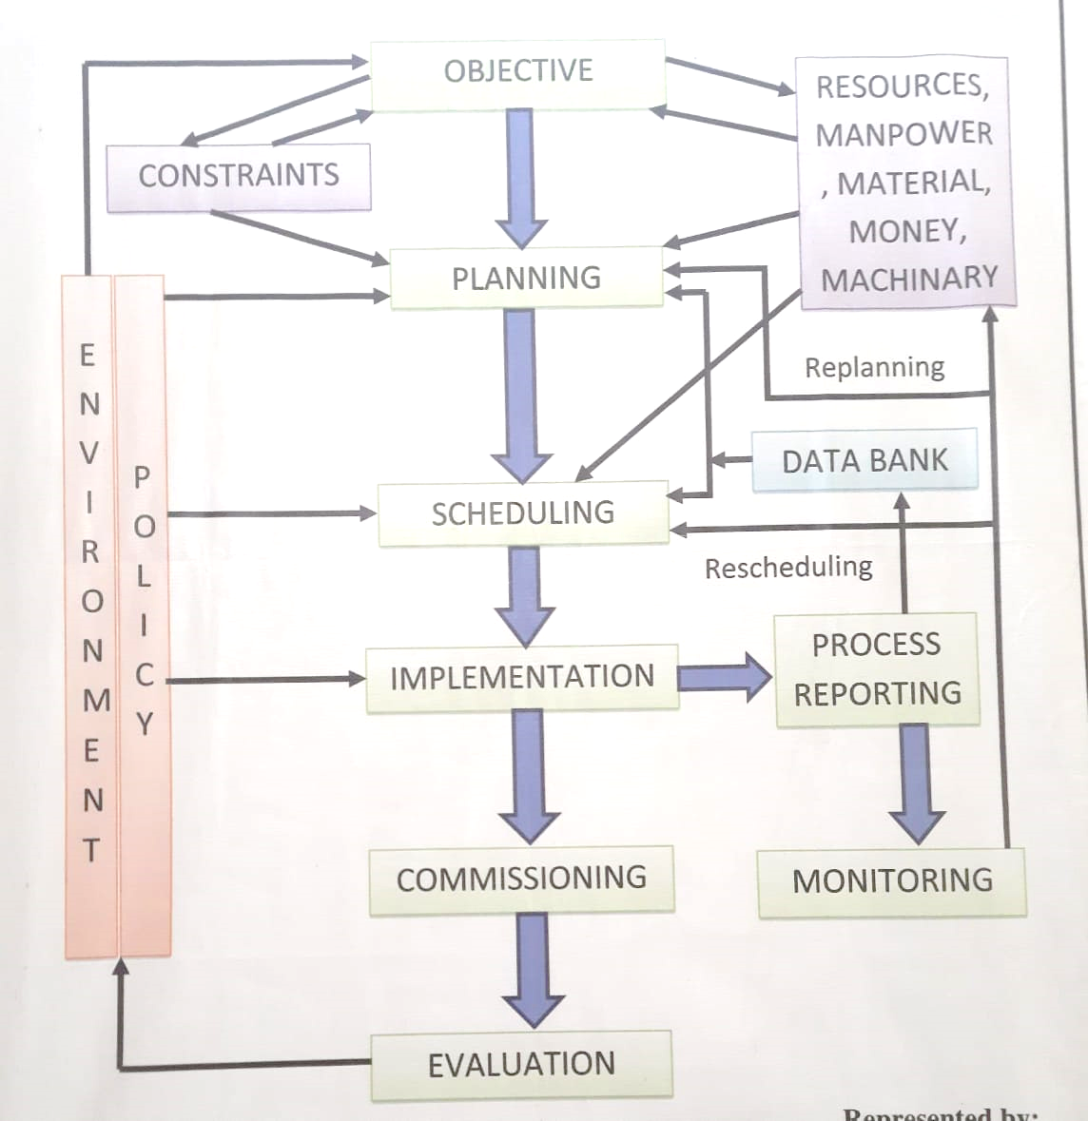

**Objectives -:**

* 1)To develop a monitoring system for the electroplating bath.
* To transfer the data sensed by the sensors to electroplating plant office through wireless technology

**Environment Policy -:**

* Time availability for the project
* Different factors affecting industrial timing (such as change in production cycle of the industry)
* Various factors affecting the academic calender of MSBTE
* Atmospheric and natural issues

**Planning –:**

* Project planning will be according to given action plan

|  |  |  |  |  |  |  |
| --- | --- | --- | --- | --- | --- | --- |
| **Sr No** | | **Detail Activity** | **Planned**  **Start date** | | | **Planned**  **End Date** |
| **1** | | **Selecting capston project** | **24-08-2020** | | | **21-09-2020** |
| **2** | | **Discussion of project with mentor** | **22-9-2020** | | | **12-10-2020** |
| **3** | | **Finalization of topic from mentor** | **13-10-2020** | | | **30-10-2020** |
| **When we discuss about our capstone project with industry then industry has given own problem ststement then we cancel then we cancel out topic and start with industry problem** | | | | | | |
| **1** | **Seeking for industry to get technical guidance and problem ststement** | | | **27-12-2020** | **27-12-2020** | |
| **2** | **Selecting topic for project** | | | **27-12-2020** | **01-01-2021** | |
| **3** | **Discussion of project with mentor** | | | **01-01-2021** | **04-01-2021** | |
| **4** | **Submitting the proposal of the project** | | | **06-01-2021** | **06-01-2021** | |
| **5** | **Study of the resources required for the project** | | | **7-1-2021** | **12-01-2021** | |
| **6** | **Study and selection of the hardware and software required for the project** | | | **13-01-2021** | **20-01-2021** | |
| **7** | **Preparation of the report on capstone project planning** | | | **21-01-2021** | **26-01-2021** | |
| **8** | **Submission of the report on capstone project planning** | | | **27-01-2021** | **28-01-2021** | |
| **9** | **Reporting the industrial executive about project planning done and ask his review on planning** | | | **28-01-2021** | **15-02-2021** | |
| **10** | **Simulation of the project** | | | **24-03-2021** | **29-03-2021** | |
| **11** | **Reporting the industrial executive for project programming and simulation done** | | | **27-03-2021** | **05-04-2021** | |
| **12** | **Inspection of simulation project under industry executive surveillance** | | | **02-04-2021** | **05-04-2021** | |
| **13** | **Actual implementing the project** | | | **05-04-2021** | **30-04-2021** | |
| **14** | **Final submission of the project** | | | **01-05-2021** | **20-05-2021** | |

**Scheduling-:**

Project scheduling include two major term

**1st term** i.e5th sem from the month of August 2020 to January 2021 includes Capstone project planning. The activities in capstone project planning consist of

* Formation of group for project
* Seeking to industries to get live problem statement
* Selection of the capstone project
* Discussing with the industry mentor and with project guide in collage for selecting the resourses , hardware software and components for project
* Preparing and submitting the planning report

**2nd Term** i.e 6th sem form month of March 2021 to May2021 includes capstone project execution . The activities in capstone project execution consist of

* Simulation of the project
* Purchasing the components required for the project
* Implementation of the project in industry
* Submitting the report on implementation of the project

**Implementation-:**

|  |  |  |
| --- | --- | --- |
| **Sr no** | **Activities** | **Implemented / not implemented** |
| 1 | Formation of the project group | **Implemented** |
| 2 | Seeking to industries to get live problem statement | **Implemented** |
| 3 | Selection of the project | **Implemented** |
| 4 | Propose planning for the project | **Implemented** |
| 5 | Selection of the resources required for the project | **Implemented** |
| 6 | Submission of the report on the capstone project planning | **not implemented** |
| 7 | simulation of the project | **not implemented** |
| 8 | Purchasing the components required for the project | **not implemented** |
| 9 | Implementation of the project in industry | **not implemented** |
| 10 | Submitting the report on implementation of the project | **not implemented** |

**Commissioning-:**

Commissioning of the project will be in the month of May 2021

Before the commissioning assembly of the project & programming will be done

**Process reporting -:**

After the formation of the group for project and securing the problem statement from the Spectrum Electrical Industries Pvt. Ltd. Study of the electroplating plant

**Block diagram of the system**

RF Transmitter

Controller (Arduino)

Sensors

Alarms

LCD display

Controller (Arduino)

RF Receiver

**Detailed Component Description**

1. **Arduino Uno**

The Arduino Uno is an [open-source](https://en.wikipedia.org/wiki/Open-source) [microcontroller board](https://en.wikipedia.org/wiki/Microcontroller_board) based on the [Microchip](https://en.wikipedia.org/wiki/Microchip_Technology) [ATmega328P](https://en.wikipedia.org/wiki/ATmega328P) microcontroller and developed by [Arduino.cc](https://en.wikipedia.org/wiki/Arduino). The board is equipped with sets of digital and analog [input/output](https://en.wikipedia.org/wiki/Input/output) (I/O) pins that may be interfaced to various [expansion boards](https://en.wikipedia.org/wiki/Expansion_board) (shields) and other circuits. The board has 14 digital I/O pins (six capable of [PWM](https://en.wikipedia.org/wiki/Pulse-width_modulation) output), 6 analog I/O pins, and is programmable with the [Arduino IDE](https://en.wikipedia.org/wiki/Arduino#Software) (Integrated Development Environment), via a type B [USB cable](https://en.wikipedia.org/wiki/USB_cable). It can be powered by the USB cable or by an external [9-volt battery](https://en.wikipedia.org/wiki/9-volt_battery), though it accepts voltages between 7 and 20 volts. It is similar to the [Arduino Nano](https://en.wikipedia.org/wiki/Arduino_Nano) and Leonardo. The hardware reference design is distributed under a [Creative Commons](https://en.wikipedia.org/wiki/Creative_Commons) Attribution Share-Alike 2.5 license and is available on the Arduino website. Layout and production files for some versions of the hardware are also available.

|  |  |
| --- | --- |
|  | |
| Arduino Uno SMD R3 | |
| Developer | Arduino |
| Manufacturer | Many |
| Type | [Single-board microcontroller](https://en.wikipedia.org/wiki/Single-board_microcontroller)[[1]](https://en.wikipedia.org/wiki/Arduino_Uno#cite_note-Makerspace-1) |
| Retail availability | <https://store.arduino.cc/usa/> |
| [Operating system](https://en.wikipedia.org/wiki/Operating_system) | None |
| [CPU](https://en.wikipedia.org/wiki/Central_processing_unit) | [Microchip](https://en.wikipedia.org/wiki/Microchip_Technology) [AVR](https://en.wikipedia.org/wiki/AVR_microcontrollers) (8-bit) |
| Memory | [SRAM](https://en.wikipedia.org/wiki/Static_random-access_memory) |
| Storage | [Flash](https://en.wikipedia.org/wiki/Flash_memory), [EEPROM](https://en.wikipedia.org/wiki/EEPROM) |

**Specifications**

|  |  |
| --- | --- |
| Brand Name | iduino |
| Compatible Devices | PC |
| Connector Type | USB |
| Number of Items | 1 |
| Part Number | arduino-001 |

It contains everything needed to support the microcontroller; simply connect it to a computer with a USB cable or power it with a AC-to-DC adapter or battery to get started.Digital I/O Pins 14 (of which 6 provide PWM output).Analog Input Pins 6.DC Current per I/O Pin 40 mA.DC Current for 3.3V Pin 50 mA.Flash Memory 32 KB (ATmega328) of which 0.5 KB used by bootloader.SRAM 2 KB (ATmega328).EEPROM 1 KB (ATmega328).Clock Speed 16 MHz.

**General pin functions**

**LED**: There is a built-in LED driven by digital pin 13. When the pin is high value, the LED is on, when the pin is low, it is off.

**VIN:** The input voltage to the Arduino/Genuino board when it is using an external power source (as opposed to 5 volts from the USB connection or other regulated power source). You can supply voltage through this pin, or, if supplying voltage via the power jack, access it through this pin.

**5V:** This pin outputs a regulated 5V from the regulator on the board. The board can be supplied with power either from the DC power jack (7 - 20V), the USB connector (5V), or the VIN pin of the board (7-20V). Supplying voltage via the 5V or 3.3V pins bypasses the regulator, and can damage the board.

**3V3:** A 3.3 volt supply generated by the on-board regulator. Maximum current draw is 50 mA.

**GND**: Ground pins.

**IOREF:** This pin on the Arduino/Genuino board provides the voltage reference with which the microcontroller operates. A properly configured shield can read the IOREF pin voltage and select the appropriate power source, or enable voltage translators on the outputs to work with the 5V or 3.3V.

**Reset:** Typically used to add a reset button to shields that block the one on the board

**Special pin functions**

Each of the 14 digital pins and 6 analog pins on the Uno can be used as an input or output, under software control (using pinMode(), digitalWrite(), and digitalRead() functions). They operate at 5 volts. Each pin can provide or receive 20 mA as the recommended operating condition and has an internal pull-up resistor (disconnected by default) of 20-50K ohm. A maximum of 40mA must not be exceeded on any I/O pin to avoid permanent damage to the microcontroller. The Uno has 6 analog inputs, labeled A0 through A5; each provides 10 bits of resolution (i.e. 1024 different values). By default, they measure from ground to 5 volts, though it is possible to change the upper end of the range using the AREF pin and the analogReference() function.

1. **Temperature sensor**

A temperature sensor is an electronic device that measures the temperature of its environment and converts the input data into electronic data to record, monitor, or signal temperature changes. There are many different types of temperature sensors. Some temperature sensors require [direct contact](https://www.electronics-tutorials.ws/io/io_3.html) with the physical object that is being monitored (contact temperature sensors), while others indirectly measure the temperature of an object (non-contact temperature sensors).

**Working principle temperature sensor**

The basic principle of working of the temperature sensors is the voltage across the diode terminals. If the voltage increases, the temperature also rises, followed by a voltage drop between the transistor terminals of base and emitter in a diode.

Besides this, Encardio-Rite has a vibrating wire temperature sensor that works on the principle of stress change due to temperature change.

The vibrating wire temperature meter is designed on the principle that dissimilar metals have a different linear coefficient of expansion with temperature variation.

It primarily consists of a magnetic, high tensile strength stretched wire, the two ends of which are fixed to any dissimilar metal in a manner that any change in temperature directly affects the tension in the wire and, thus, its natural frequency of vibration.

The dissimilar metal, in the case of the Encardio-Rite temperature meter, is aluminium (Aluminum has a larger coefficient of thermal expansion than steel.) As the temperature signal is converted into frequency, the same read-out unit which is used for other vibrating wire sensors can also be used for monitoring temperature also.

The change in temperature is sensed by the specially built Encardio-rite vibrating wire sensor and is converted to an electrical signal which is transmitted as a frequency to the read-out unit.

The frequency, which is proportional to the temperature and in turn to the tension ‘σ’ in the wire, can be determined as follows:

f = 1/2 [σg/ρ] / 2l Hz

Where:

σ = tension of the wire

g = acceleration due to gravity

ρ = density of the wire

l = length of wire

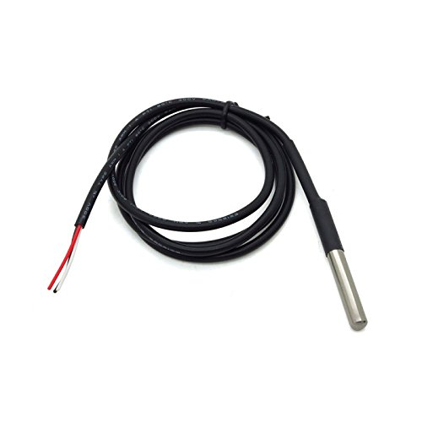

##### **Specifications for this item**

|  |  |
| --- | --- |
| Brand Name | Robotbanao.com |
| Ean | 0689786540551 |
| Included Components | Waterproof Digital Temperature Thermal Probe Sensor For Arduino |
| Item Weight | 200 grams |
| Number of Items | 1 |
| Part Number | ESC037 |
| UPC | 689786540551 |

It is 912 adjustable resolution power supply range: 3.0v 5.5v operating temperature range: 55 deg. C +125 deg. C ( 67 degree f +257 degree f) storage temperature range: 55 deg. C to 125 deg. C ( 67 deg. F +257 deg. F) accuracy over the range of 10 degree c to +85 degree c: 0.5 degree c. No other components, unique single bus interface output lead: red (vcc), yellow(data) , black(gnd) cable length: approx.100 cm.

## **Product details**

* Product Dimensions : 10 x 8 x 4 cm; 200 Grams
* Date First Available : 23 July 2018
* Manufacturer : ROBOTBANAO
* ASIN : B07FSNS1SG
* Item part number : ESC037
* Country of Origin : India
* Manufacturer : ROBOTBANAO, Sound Corp. .,Guishan Township,Taoyuan County 33383 Ph- 886-3-396-1959 Taiwan R. O. C.
* Packer : GALAXY GIFTS AND NOVELTIES HOUSE NO. 8754 GALI NO. 14B KAROL BAGH SIDHIPURA DELHI - 110012
* Importer : GALAXY GIFTS AND NOVELTIES HOUSE NO. 8754 GALI NO. 14B KAROL BAGH SIDHIPURA DELHI - 110012
* Item Weight : 200 g
* Item Dimensions LxWxH : 10 x 8 x 4 Centimeters
* Net Quantity : 1 Piece
* Included Components : Waterproof Digital Temperature Thermal Probe Sensor For Arduino
* Generic Name : Temperature Controllers

1. **Methane gas sensor**

This semiconductor gas sensor detects the presence of methane (CNG) gas at concentrations from 300 ppm to 10,000 ppm, a range suitable for detecting gas leaks. The sensor's simple analog voltage interface requires only one analog input pin from your microcontroller. Compare all products in Gas Sensors.

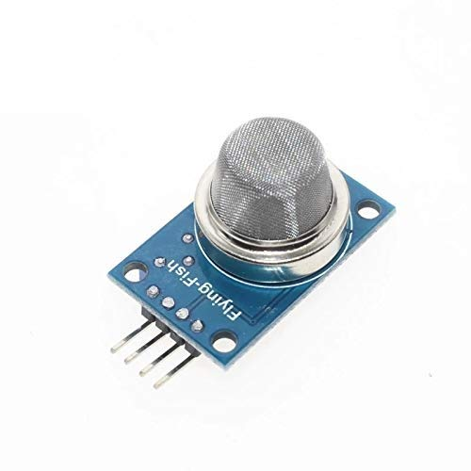

MQ-2 gas sensor sensitive material is low conductivity tin oxide (SnO2). When there is combustible gas in the environment, conductivity of the sensor increases. Use a simple circuit to convert the change in conductivity of the gas concentration corresponding to the output signal. MQ-2 gas sensor is high on gas, propane, hydrogen sensitivity of detection of natural gas and other flammable vapours are also very good. This sensor can detect a variety of flammable gas. Gas Sensor may be used in homes and factories leakage monitoring device suitable for the detection of gas, butane, propane, methane, smoke, etc.

**Specifications:**Input Voltage: DC5V Power consumption (current): 150mA  
DO Output: TTL digital 0 and 1 (0.1 and 5V)  
AO Output: 0.1 - 0 .3 V (relative to pollution), the maximum concentration has a voltage of about 4V

**Special Note:**  
After the sensor is powered, needs to warm up around 20S, measured data was stable, heat sensor is a normal phenomenon, because the internal heating wire, if hot is not normal

**Pinout:**  
VCC: positive power supply (5V)  
GND: power supply is negative  
DO: TTL switching signal output  
AO: Analog signal output

**Technical Details**

|  |  |
| --- | --- |
| Brand | EHUB |
| Manufacturer | Generic |
| Model | MQ2 |
| Package Dimensions | 200 x 200 x 100 cm; 8 Grams |
| Item model number | MQ2 |
| Batteries Included | No |
| Batteries Required | No |
| Has Auto Focus | No |
| Programmable Buttons | No |
| Manufacturer | Generic |

1. **Analog PH Sensor Kit**

The Analog pH Sensor Kit is specially designed for Arduino controllers and has a built-in simple, convenient, and practical connection and features. It has an LED that works as the Power Indicator, a BNC connector, and a PH2.0 sensor interface. To use it, just connect the pH sensor with the BND connector, and plug the PH2.0 interface into the analog input port of any Arduino controller. If pre-programmed, you will get the pH value easily. Comes in a compact plastic box with foams for better mobile storage. This is a laboratory probe, it cant be immersed in the liquid for a too long time.

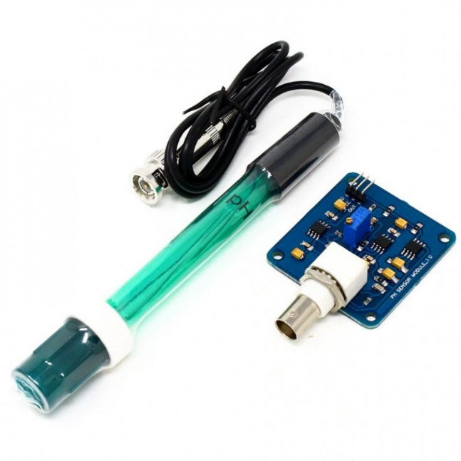

**Applications**

* Water quality testin
* Aquaculture

**Step to Use the pH Meter:**

**Cautions:**

* Please use an external switching power supply, and the voltage as close as possible to the +5.00V. More accurate the voltage, the higher the accuracy!
* Before the electrode in continuous use every time, you need to calibrate it by the standard solution, in order to obtain more accurate results. The best environment temperature is about 25 , and the pH value is known and reliable, close to the measured value. If you measure the acidic sample, the pH value of the standard solution should be 4.00. If you measure the alkaline sample, the pH value of the standard solution should be 9.18.Subsection calibration, just in order to get better accuracy.
* Before the pH electrode measured different solutions, we need to use water to wash it. We recommend using deionized water.

1. Connect equipment according to the graphic, that is, the pH electrode is connected to the BNC connector on the pH meter boardand then use the connection lines, the pH meter board is connected to the analog port 0 of the Arduino controller. When the Arduino controller gets power, you will see the blue LED on board is on.
2. Upload the sample code to the Arduino controller.
3. Put the pH electrode into the standard solution whose pH value is 7.00or directly shorted the input of the BNC connector. Open the serial monitor of the Arduino IDE, you can see the pH value printed on it, and the error does not exceed 0.3. Record the pH value printed, then compared with 7.00, and the difference should be changed into the Offset in the sample code. For example, the pH value printed is 6.88, so the difference is 0.12. You should change the # define Offset 0.00 into # define Offset 0.12 in your program.
4. Put the pH electrode into the pH standard solution whose value is 4.00. Then wait about one minute, adjust the gain potential device, let the value stabilize at around 4.00. At this time, the acidic calibration has been completed and you can measure the pH value of an acidic solution.

**Note: If you want to measure the pH value of other solutions, you must wash the pH electrode first!**

* According to the linear characteristics of the pH electrode itself, after the above calibration, you can directly measure the pH value of the alkaline solution, but if you want to get better accuracy, you can recalibrate it. The alkaline calibration uses the standard solution whose pH value is 9.18. Also, adjust the gain potential device, let the value stabilize at around 9.18. After this calibration, you can measure the pH value of the alkaline solution.

**Specifications:-**

|  |  |
| --- | --- |
| Input Supply voltage (VDC) | 5 |
| Module Size (mm) | 50 x 47 x 16 |
| Measuring Range | 0 14 PH |
| Measuring Temperature | 0 50 |
| Accuracy | 0.01 pH |
| Response Time | 1min |
| Cable Length (cm) | 75 |
| pH sensor size (mm) | 150, 12 |

1. **Carbon Monoxide Sensor**

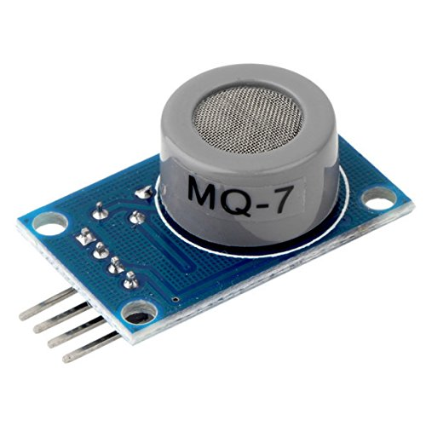

MQ-7 CO Carbon Monoxide Coal Gas Sensor Module detects the concentrations of CO in the air and outputs its reading as an analog voltage. The sensor can measure concentrations of 10 to 10,000 ppm.

The sensor can operate at temperatures from -10 to 50°C and consumes less than 150 mA at 5 V.

This module provides both digital and analog outputs. The threshold level for digital output can be easily adjusted using the preset on the board. The MQ-7 sensor module can be easily interfaced with Micro-controllers, Arduino and etc.

Sensitive material of MQ-7 gas sensor is SnO2, which with lower conductivity in clean air. It make detection by method of cycle high and low temperature, and detect CO when low temperature (heated by 1.5V). The sensor's conductivity is higher along with the gas concentration rising. When high temperature (heated by 5.0V), it cleans the other gases adsorbed under low temperature. Please use simple electro circuit, Convert change of conductivity to correspond output signal of gas concentration. Good sensitivity to Combustible gas in wide range High sensitivity to Natural gas Long life and low cost Simple drive circuit MQ-7 gas sensor has high sensitivity to Carbon Monoxide. The sensor could be used to detect different gases contains CO, it is with low cost and suitable for different application. Technical parameters: Power supply needs: 5V Interface type: Analog Pin Definition: 1-Output 2-GND 3-VCC High sensitivity to carbon monoxide

**Features :**

* The analog output voltage, the higher the concentration the higher the voltage.
* The carbon monoxide detection with better sensitivity.
* There are four screw holes for easy positioning.
* With a long service life and reliable stability.
* Rapid response and recovery characteristics.

**specifications for this item**

|  |  |
| --- | --- |
| Brand Name | ADRAxX |
| Colour | Multicolor |
| Ean | 0000810008074 |
| Item Shape | Rectangle |
| Model Number | MQ7 |
| Number of Items | 1 |
| Part Number | MQ7 |
| Size | Standerd |
| Specification Met |  |
| UPC | 000810008074 |

**Product details**

1. Is Discontinued By Manufacturer : No
2. Package Dimensions : 13.8 x 6 x 1 cm; 20 Grams
3. Date First Available : 14 April 2017
4. Manufacturer : Adraxx
5. ASIN : B071D2MQPW
6. Item model number : MQ7
7. Country of Origin : China
8. Manufacturer : Adraxx
9. Item Weight : 20 g
10. **RF Transmitter Receiver**

**DESCRIPTION:**  
This hybrid 433Mhz RSI Wireless Transmitter Receiver Module provides a complete RF transmitter and receiver module solution which can be used to transmit data at up to 3KHz from any standard CMOS/TTL source.  
The RX – ASK is an ASK Hybrid receiver module. The RF Transceiver Module is an effective low-cost solution for using 433 MHz. The TX-ASK is an ASK hybrid transmitter module. TX-ASK is designed by the saw resonator, with an effective low cost, small size and simple to use for designing.

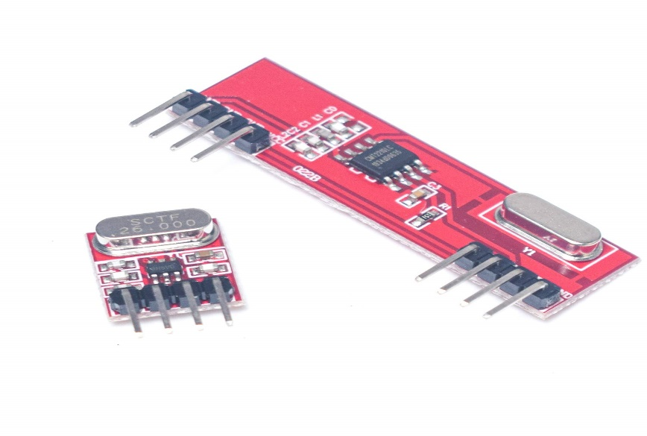

**Specifications for this item**

|  |  |
| --- | --- |
| Brand Name | REES52 |
| Colour | RED |
| Finish Type | Finished |
| Item Thickness | 4.00 millimeters |
| Material | fabricate PCBs |
| Model Number | RF 443 mhz Transmitter Receiver Module |
| Number of Items | 2 |
| Part Number | REES-RC035 |
| Power Source Type | Receiver Operating Voltage(V) :5 ; Transmitter Supply Voltage(V) :3 to 6 |
| Size | TX:RX Module Size(mm) =13x12x4 : 13x45x4 (LxWxH) |
| Special Features | Range in open space: 30 Meters |
| Specific Uses For Product | Transmitter And Receiver |
| Style | RF Transmitter And Receiver module |

**Specification**

* Range in Open Space(m): 30
* Transmitter Frequency Range(MHz): 433.92
* Receiver Frequency Range(MHz): 433
* Sensitivity: 105 dBm
* Receiver Supply Current(mA): 3.5
* RX IF Frequency(MHz): 1
* Receiver Operating Voltage(V): 5
* Transmitter Supply Voltage(V): 3 to 6
* Transmitter Output Power(dBm): 4 to 12
* TX Module Size(mm): 13x12x4 (LxWxH)
* RX Module Size(mm): 13x45x4 (LxWxH)
* Weight(gm): 6

**Applications :**

* Remote Controls
* Automation System
* Wireless Security System
* Sensor Reporting
* Car Security System
* Remote Keyless Entry

**Features :**

* Low Power Consumption.
* Easy For RF-based Application.
* Complete Radio Transmitter.
* Transmit Range Up To 50m.
* CMOS / TTL Input.
* No Adjustable Components.
* Very Stable Operating Frequency
* Low Current Consumption (Typ 11mA)
* Wide Operating Voltage (1.5-5v)
* ASK Modulation

1. **LCD**

Stands for "Liquid Crystal Display." LCD is a flat panel display technology commonly used in TVs and computer monitors. It is also used in screens for mobile devices, such as laptops, tablets, and smartphones .

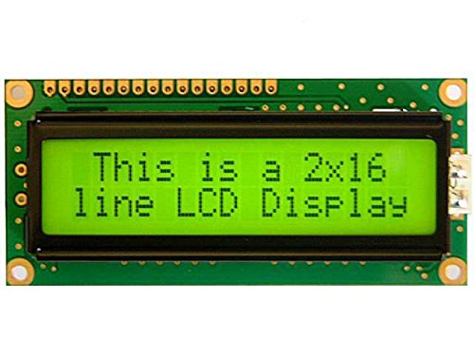

5V DC 16 x 2 Lines ASCII Character LCD Display With Yellow Backlight Product Description: o LCD display module with Yellow Backlight o SIZE : 20x4 (2 Rows and 16 Characters Per Row) o Can display 2-lines X 16-characters o Operate with 5V DC o Wide viewing angle and high contrast o Built-in industry standard HD44780 equivalent LCD controller o Commonly Used in: Student Project, Collage,copiers, fax machines, laser printers, industrial test equipment, networking equipment such as routers and storage devices o LCM type: Characters ABOUT This is a basic 16 character by 2 line display Yellow Back light . Utilizes the extremely common HD44780 parallel interface chipset (datasheet). Interface code is freely available. You will need 7 general I/O pins(If use in 4-bit Mode) to interface to this LCD screen. Includes LED backlight. Package Contains: 1 X 16X2 LCD.

**Specifications for this item**

|  |  |
| --- | --- |
| Brand Name | Silicon TechnoLabs |
| Colour | Yellow |
| Compatible Devices | Microcontrollers |
| Included Components | LCD 16X2 |
| Item Weight | 35.0 grams |
| Model Number | ST/16x2Y |
| Number of Items | 1 |
| Part Number | ST/16x2Y |
| Power Source Type | Dc |
| Special Features | LCD display module with Yellow Backlight , SIZE : 20x4 (2 Rows and 16 Characters Per Row) , Can display 2-lines X 16-characters , Operate with 5V DC , Wide viewing angle and high contrast , Built-in industry standard HD44780 equivalent LCD controller , Commonly Used in: Student Project, Collage,copiers, fax machines, laser printers, industrial test equipment, networking equipment such as routers and storage devices , LCM type: Characters |
| Specification Met |  |
| Voltage | 5 volts |

**Details**

* Is Discontinued By Manufacturer : No
* Product Dimensions : 16 x 2 x 2 cm; 35 Grams
* Date First Available : 30 April 2015
* Manufacturer : Sound Land Corp
* ASIN : B00XT53RI0
* Item model number : ST/16x2Y
* Manufacturer : Sound Land Corp, Sound Land Corp. No.32.Keji 1st Rd.,Guishan Township,Taoyuan County 33383 Ph- 886-3-396-1958 Taiwan R. O. C.
* Packer : Sound Land Corp. No.32.Keji 1st Rd.,Guishan Township,Taoyuan County 33383 Ph- 886-3-396-1958 Taiwan R. O. C.
* Importer : GALAXY GIFTS AND NOVELTIES HOUSE NO. 8754 GALI NO. 14B KAROL BAGH SIDHIPURA DELHI - 110005 mo.-8989713946
* Item Weight : 35 g

**Action plan**

|  |  |  |  |  |  |  |
| --- | --- | --- | --- | --- | --- | --- |
| **Sr No** | | **Detail Activity** | **Planned**  **Start date** | | | **Planned**  **End Date** |
| **1** | | **Selecting capston project** | **24-08-2020** | | | **21-09-2020** |
| **2** | | **Discussion of project with mentor** | **22-9-2020** | | | **12-10-2020** |
| **3** | | **Finalization of topic from mentor** | **13-10-2020** | | | **30-10-2020** |
| **When we discuss about our capstone project with industry then industry has given own problem ststement then we cancel then we cancel out topic and start with industry problem** | | | | | | |
| **1** | **Seeking for industry to get technical guidance and problem ststement** | | | **27-12-2020** | **27-12-2020** | |
| **2** | **Selecting topic for project** | | | **27-12-2020** | **01-01-2021** | |
| **3** | **Discussion of project with mentor** | | | **01-01-2021** | **04-01-2021** | |
| **4** | **Submitting the proposal of the project** | | | **06-01-2021** | **06-01-2021** | |
| **5** | **Purchasing the components** | | | **7-1-2021** |  | |
| **6** | **Simulation of the project** | | |  |  | |
| **7** | **Discuss about programming with industry guide** | | |  |  | |
| **8** | **Checking of simulation project under industry guide** | | |  |  | |
| **9** | **Actual implementing the project** | | |  |  | |
| **10** | **Final submission of the project** | | |  |  | |